GETTING TO KNOW FUNCTION

Function is critical to communication in biomimetric design. Function is the pivot between life’s wisdom and what we are trying to achieve intentionally. The first step in applying a biomimicry approach to your design or challenge is to identify what you want your design to do. It is VERY important to identify the real challenge of “what do you want your design to DO?” This is very different from “What do you want to design?”

In this exercise, you will practice identifying the function of a design. As you read through each of the statements, as what it is the “design” needs to do. It is likely that your FUNCTIONS will be verbs. There may be several correct answers for each example, but don’t spend too much time thinking over these:

1. There are too many plastic drink bottles in our trash and we want to find a solution that will result in less trash.
___________________________________
2. Some people don’t want Raid on the shelf in their home, but they don’t want bugs either.
___________________________________
3. Xcel Energy wants to build a large solar plant in the San Luis Valley.
___________________________________
4. A river channel built by the Army corps of Engineers is too small and needs to be enlarged.
___________________________________
5. Our school district wants to place recycling bins in local elementary schools.
___________________________________
6. The U.S. Forest Service wants to “right size” their fleet of vehicles.
___________________________________

7. A dirt road in my community is bumpy and needs to be paved.
___________________________________
8. The National Park Service wants to stock Medano Creek with native fish.
___________________________________
9. Plastic bottles are about to be banned because they contain BPA.
___________________________________
10. I set the curfew for my teenage son at 12;00 AM on weekends.
___________________________________
11. I can’t sell my fabrics in Europe because the dyes contain heavy metals.
___________________________________
12. Since the new housing development was built, we need to add another wastewater treatment plant.
___________________________________
13. Our county wants to recycle building materials from houses that are to be demolished.
___________________________________
14. I want to bring people in my community closer to Nature.
___________________________________
15. Flower spread their DNA via seed dispersal.
___________________________________

GETTING TO KNOW FUNCTION
Looking at Native American Activities

Introduction: When the white man came to the San Luis Valley it was held by the Utah Indians who were often called the Blue Sky People by both their friends and enemies. There were seven tribes which occupied or at least frequently visited the area. They were Apache, Arapahoe, Cheyenne, Comanche, Kiowa, Navajo, and Utah. Many of these tribes were nomadic, returning to the same campsite every year. Other tribes that used the area in southwestern Colorado included the Hopi, Tohono-O’odham, Yaqui, Zuni, Tewa and others.

The view of these people is that man is a part of a delicately balanced universe in which all compounds, all life forms and natural elements interrelate and interact, with no parts being more or less important than another. Further, it is believed that only man can upset this balance. These native people use ceremony, arts and crafts and storytelling to reinforce this philosophy and incorporate it into the functions they perform in their day-to-day life.

Identifying Function Exercise: This exercise is designed to help you identify what function the rituals of the native people were designed to perform. Two examples are provided below. With a partner, use the books provided to select one ritual and identify the function that the native people are trying to achieve.

Examples:
Ceremonials: The Deer Dance of the Tewa pueblos reflects the belief that a hunter will be unsuccessful if he does not first gain the deer’s cooperation through showing respect. After a deer is killed, further rituals ensure that the deer’s spirit will be reborn as another deer. Animals disappear only when hunted disrespectfully.

Functions: Transfer knowledge, reinforce spiritual views, promote prosperity, warn against overhunting.
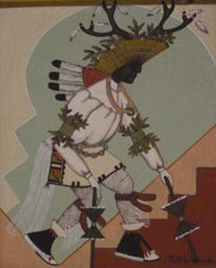

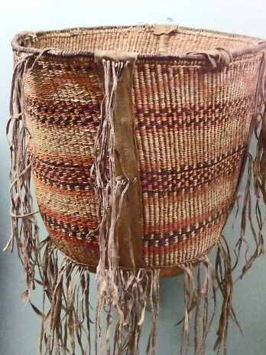
Crafts: Basket making is used to preserve the native culture, materials and spiritual beliefs, by passing down traditional skills and knowledge to each generation. The tinklers on Apache burden baskets made noise to avoid startling bears while carrying heavy loads in their mountainous homelands. Women told stories, represented in the basket weave design, to the young girls as they taught them to weave the baskets.

Functions: Transfer knowledge, decoration, make noise, carry food.

