Function and Abstract Worksheet
Biomimicry Workshop 2012
Homework due July 13, 2012

Abstracting is one of the most critical components of practicing biomimicry and also one of the most difficult. After you have identified an acceptable suite of possibilities by accessing biological literature, by working with Nessly and researching the biological literature as a team, or by observing nature, the most important step follows. Biology by itself is interesting, but were you just to hand it over to the design team, most designers wouldn’t know what to do with it. An additional step of translation is now necessary.

When you read a case study, the creating process seems easy and obvious, but the emulation of a natural strategy with a human solution requires an understanding of the biology, a translation to design principles, and then a good dose of creativity. We call this phase abstracting.

The abstracting step includes two components:
  - distilling the biological mechanism
  - translating them into design principles
\
Practice identifying the function and abstracting the design principles from the examples below. Work with your team, remember, multiple disciplines bring more to the brainstorm than working alone. I have included the “cheat sheet” in a separate file so you can check your work and/or find the answer if you cannot.

1. Ants are social insects that achieve highly complex and efficient workforce allocation without centralized control. The Pharaoh Ants optimized resource allocation is directed by three pheromone ‘rules’. The ants lay down a ‘searching’ trail while they forage for food. When food is found, they lay down a ‘positive’ trail. If the trail does not lead to useful resources they lay down a ‘negative’ trail. This information system works in the face of multiple food sources, at several distances that are constantly changing. The reinforcement of scent by multiple ants allows the ants to optimally exploit the richest and closest food sources using simple rules of non-linear feedback.

Function | Strategy | Design Principle

2. Tree frogs have the remarkable ability to cling to smooth wet surfaces. Their toe pads have a regular microstructure that significantly increases attachment force. The toe pads consist of regular hexagonal structures approximately 10 µM across. These hexagonal cells are separated by a 1µM channel between them, and each hexagonal cell has smaller 0.1-0.4 µM pegs that stand out from the hexagonal cell. The almost fractal nature of the structure at several levels appears to allow the most contact with the surface. The tree frog uses this ingenious design, along with a secreted mucous, to gain purchase in a slippery environment. (See illustration on next page)

Function | Strategy | Deep Principle

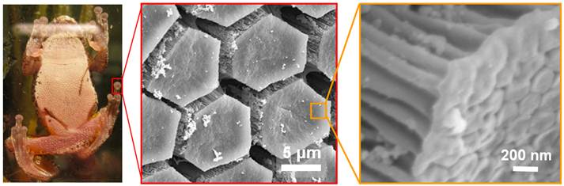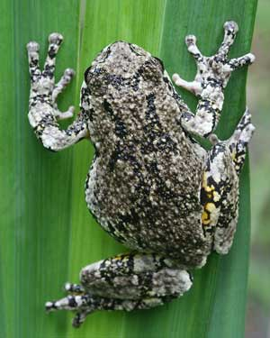

3. Cacti are known for living in harsh dry conditions, where water is infrequent. Their strategy for surviving times of drought is to store large quantities of water in their tissues. The cactus has an outer layer and an inner core both composed of more ridged cells, with smooth cell walls. The third cell layer between the two consists of collapsible cells that have a wrinkled appearance allowing cells to change volume without changing their surface. When water becomes scarce, the collapsible cells forfeit their water to the more rigid smooth cells allowing the plant to maintain its structural integrity despite changes in ambient water availability.

Function | Strategy | Deep Principle

4. Honeybees need to keep their nest between 32⁰ and 36⁰ C. Worker bees will fan air out of the nest if they perceive the temperature is too high, and will cluster together and generate heat when they perceive that the temperature is too low. Each individual honey bee worker has a unique temperature threshold. When the temperature outside begins to rise, a few bees react to the heat and start to cool down the hive. Eventually these bees’ efforts are overcome, and the hive continues to warm. As the temperature creeps higher, more bees with higher temperature thresholds react and begin fanning. The process perpetuates throughout the day, and works in reverse for heating the hive. The different temperature thresholds between bees results in a highly efficient and self-organizing system that keeps the hive temperature stable, even with wild swings in temperature outside.

Function | Strategy | Deep Principle

5. Ticks have an impressive ability to absorb moisture directly from the atmosphere, a function critical for organisms that may have to wait for a passing meal. The tick secretes a special hydrophilic gel solution from its mouth to achieve this amazing feat. The gel is a salt solution, composed primarily of Na+, K+ and Cl- that readily dehydrates when the air is dry, but when the climate changes and the humidity tops 42% the gel solution rapidly hydrates. Once the gel is hydrated, the tick swallows it, effectively drinking the water from the air.

Function | Deep Principle | Life Principle

